# Under Manage > Health Care

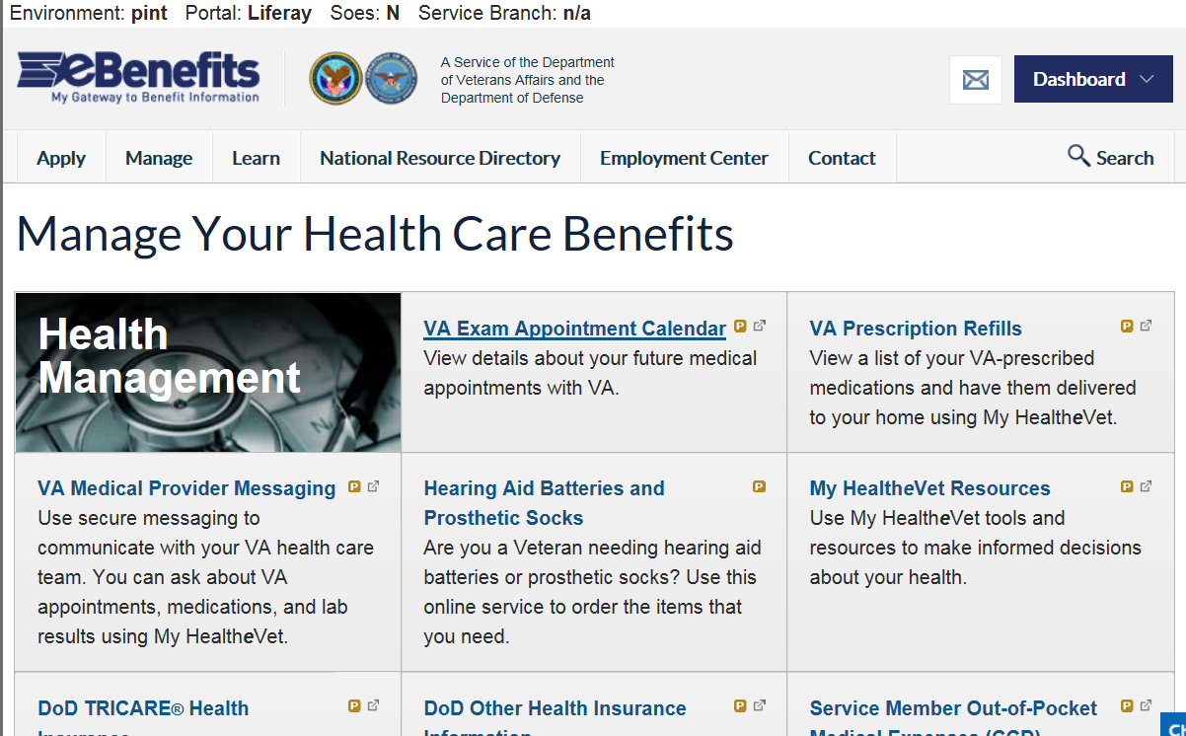

Link Direction: MHV Health Cal? Or MHV Appointments?

**New Link Text:**

**View My VA Appointments**

New Helper Text:

View details about your upcoming VA medical appointments.

# eBenefits homepage

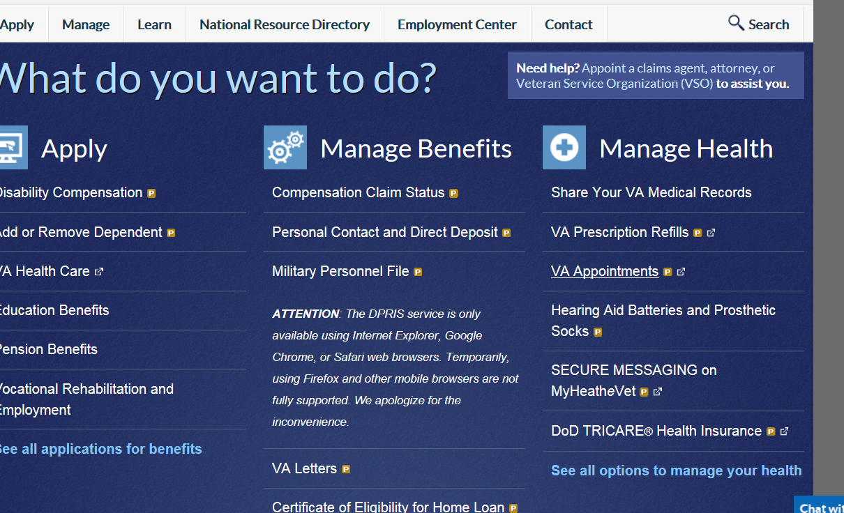

**Link Direction: “View Appointments” for logged in users, “Keeping Up With” for logged out users.**

**Change text to: View My VA Appointments**

# Under Learn > Health Care

**New text for blue boxes**

**1.** VA Exam Appointment Calendar becomes **“View My VA Appointments”**

View details about your upcoming VA medical appointments.

**2.** VA Medical Appointment Scheduling becomes **“Schedule a VA Appointment”**

Schedule VA appointments and manage your appointment schedule using My HealtheVet.

